Go to IAM console

Go to Roles

Click on Create role.

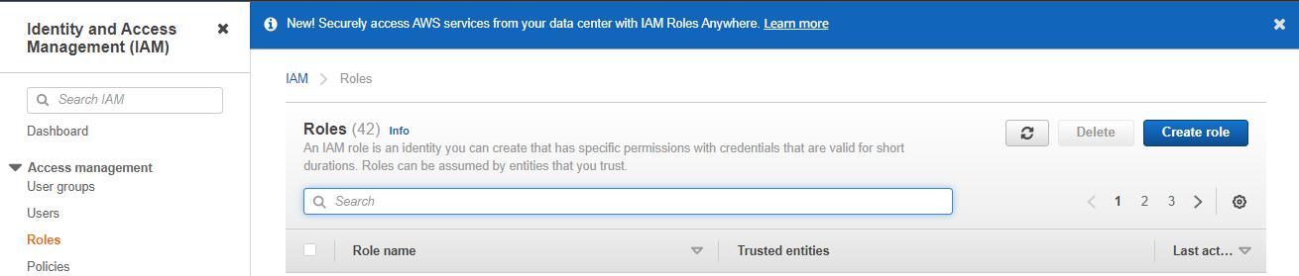

* Choose AWS service as Trusted entity type
* Choose EC2 use case.
* Click Next

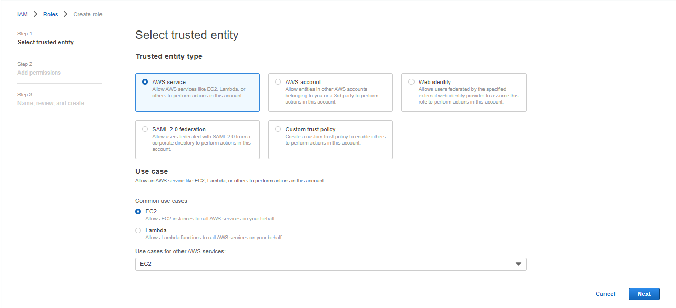

Choose IAM policy and Click Next.

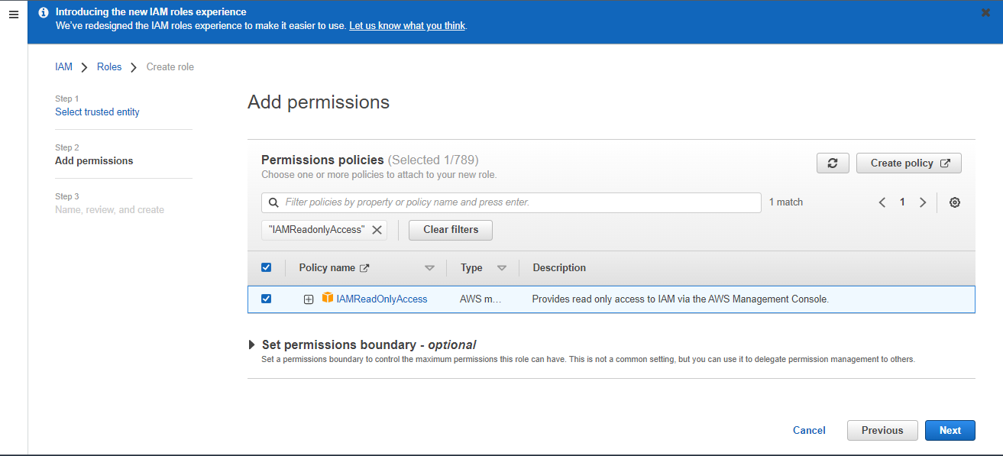

Give Role name

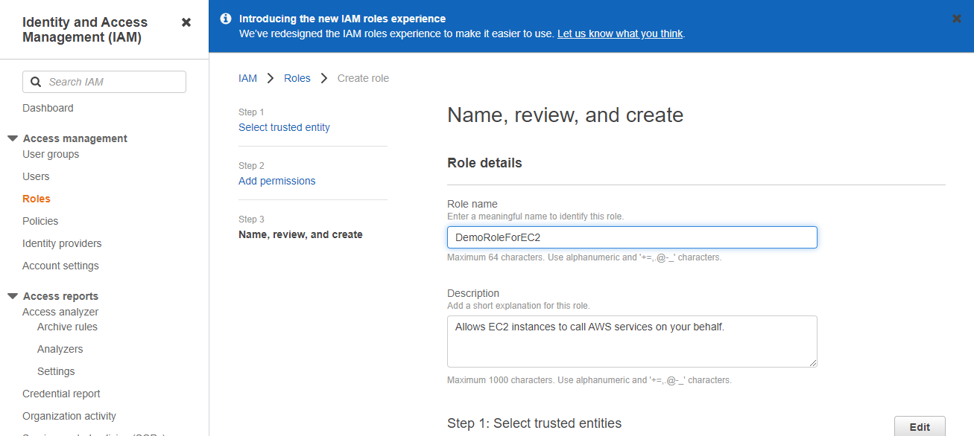

Once completed

* Click on Create role

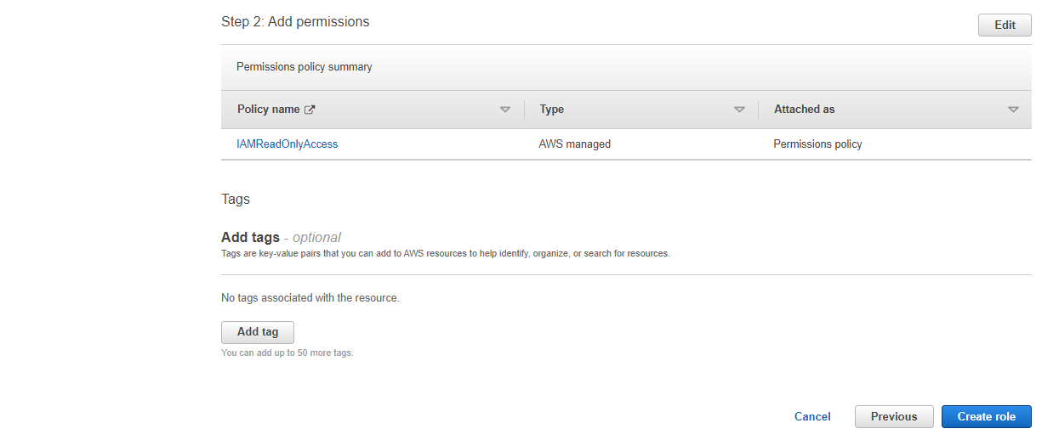

* Your role has been created.

